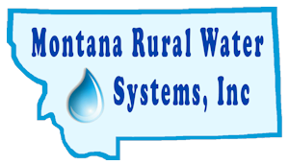
MRWS
Call for Abstracts
46th Conference
March 23-25, 2026
Submission Deadline: October 17, 2025 - Please use Microsoft Word…thanks!
Email form to Mtruralwater@mrws.org

Company Name:

Speaker’s Name(s):

Mailing Address:

Phone Number:

Email Address:

Name of Presentation:

Speaker(s) Bio:

General Description of topic:

Do you need any special equipment? (Laptop, projector, screen, & pointer provided.)

Do you have a Day/Time preference? (This does not guarantee your time but we will make every effort to get this for you.)

