Name as it will appear on Badge: __________________________________________________
Employer: _____________________________________ Operator #: _____________________
Your Title or Position: ___________________________Phone #: _________________________
Billing Address: _________________________________________________________________
City/State/Zip: __________________________________________________________________
Email to receive training and other notifications: ______________________________________
Operator Certification Review Sessions (No CEC’s) …. ______Water _____WW…. $150.00
Operator Certification Review Sessions (No CEC’s) …. ______Water _____WW…. $150.00
Operator Certification Review Sessions (No CEC’s) …. ______Water _____WW…. $150.00
Operator Certification Review Sessions (No CEC’s) …. ______Water _____WW…. $150.00

Full Registration March 12th – 14th
(Includes all classes, Exhibit Hall, meals & breaks and Meet & Greet)
Member – Early bird, payment included (By 1/17/25) ………………………………………. $250.00
After Early bird deadline……………………………………………………………………. $300.00
Non-members – Early bird, payment included (By 1/17/25) ……………………………… $375.00
After Early bird deadline …………………………………………………………. $425.00
Onsite Registration……………………………………………………………………………………………. $500.00
Guest Registration (Spouse, Significant other, child) ………………………………………… $100.00
This registration includes exhibit hall and meals only.
Name for Guest Badge: ___________________________________
Operator Certification Review Sessions (No CEC’s) …. _____Water _____WW …. $175.00
This is for people preparing to take the certification Exam.

Registration Deadline is February 21, 2025

- MRWS provides our registered Exhibitors with a list of Attendees. These Exhibitors may contact you regarding their product or service. Would you like to be included on this list? ___ Yes, please include me on the list ___ No, I would not like to be included. No response indicates approval.
- Refunds – A $50.00 fee will be charged on all refunds. Refund requests will not be processed until after the conference. Conference registrations are transferable.

If paying with a credit card, please complete the following:
Card Number: ____________________________ Expiration Date: _________________
Name as it appears on card: __________________________________________________
Billing Address: _____________________________________________________________
CSV: ___________ 3% fee for Credit Card Payments

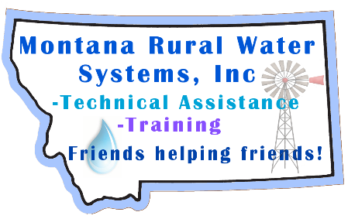
Return this form with payment to:
MRWS
9 3rd Street N. #304
Great Falls, MT 59401
406-454-1151 or Email: MTRuralWater@mrws.org

