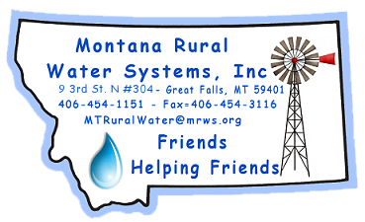
MRWS
Call for Papers
44th Conference
March 20-22, 2024
Submission Deadline: November 3, 2023 - Please use Microsoft Word…thanks!

Company Name:

Speaker’s Name(s):

Mailing Address:

Phone Number:

Email Address:

Name of Presentation: (Please make this short & Sweet!)

Speaker(s) Bio:

General Description of topic: (Please keep this short.)

Do you need any special equipment? (Laptop, projector, screen, & pointer provided.)

Do you have a Day/Time preference? (This does not guarantee your time but we will make every effort to get this for you.)

Thanks for your consideration.

