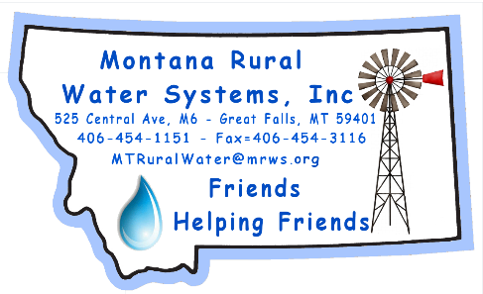
MRWS
Call for Papers
43rd Conference
March 22-24, 2023
Submission Deadline: November 4, 2022 - Please use word…thanks!

Company Name:

Speaker’s Name(s):

Mailing Address:

Phone Number:

Email Address:

Name of Presentation: (Please make this short & Sweet!)

Speaker(s) Bio:

General Description of topic:

Do you need any special equipment? (Laptop, projector, screen, & pointer provided.)
Thanks for your consideration.

